Fundraising pack
100 years of The Young Women’s Movement
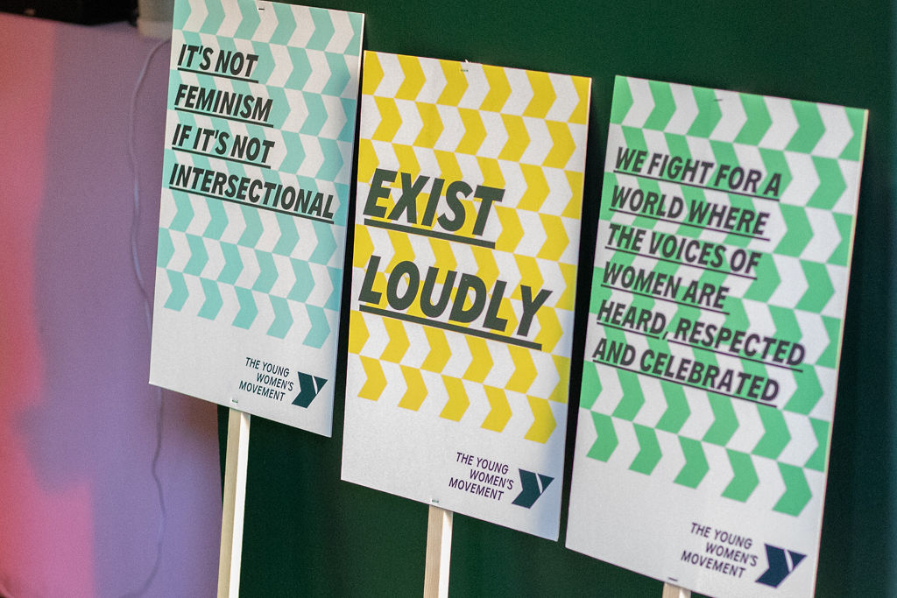

Contents
Foreword by Fatima Ishaq 2
Why fundraise for us 3
Ways to fundraise 3
Be active 3
Be together 4
Be digital 4

Foreword by Fatima Isha, Young Women Know alum and member of The Young Women’s Movement advisory collective
Dear sisters and allies,

The Young Women’s Movement is more than an organisation. It’s a community embedded in safe and supportive relationships; a movement where I, and so many women around Scotland, have been given a platform and a voice.

I first became involved with The Young Women’s Movement when I was 17. At a time where my friends and I were beginning to navigate the complexities and injustices of the world, we were given a space to explore these issues free from judgement – a chance to really influence change and raise awareness of issues important to us. I can still recall for the first time as a group we felt seen and heard, that our contributions mattered and could really make a difference.

Empowering community voices and ensuring the voices of all women are valued and heard is at the heart of all the work of this amazing organisation.

A few years have passed now, and the love I have for this organisation has meant that I have been able to stay involved and have been continually provided support and opportunities. I’ve developed confidence, I’ve found my voice and, most importantly, I’ve found a community.

By supporting The Young Women’s Movement, you are supporting an organisation with a commitment to support women and marginalised genders to reach their potential. You are supporting so many others, like me, who have gained so much from this organisation.

The Young Women’s Movement offers programmes and opportunities to countless young women and girls across Scotland. The movement amplifies the voices of young women and supports them to share their experiences, challenge inequality and strives to make Scotland the best place for young women and girls to grow.

The Young Women’s Movement needs funds to grow its reach and continue to provide unimaginable opportunities for young women.

Thank you for supporting our efforts and supporting our dream to reimagine Scotland for young women and girls.

Why fundraise for us
For 100 years, The Young Women’s Movement has been Scotland’s national organisation for young women’s feminist leadership and collective action against gender inequality.

We trace our history back to 1924 when the Scottish Council seceded from the YWCA of Great Britain and formed YWCA Scotland. Although we go by a different name today, we’re proud of everything that we’ve achieved over the last century.

Can you raise or donate £100 to help us continue our work?

The money you raise will allow us to continue to carry out our work to achieve our vision of a fairer Scotland for young women and girls. This fundraising pack is full of ideas to help you get started.

What £100 can do
Through our work, we equip young women and girls with the tools and opportunities to make change on a local and national level. We rely on funding and donations to do this work.

Some recent examples of the impact of our work include:
- The Young Women Lead Glasgow report on feminist town planning was pivotal to Glasgow becoming the first UK city to embed a feminist lens into city planning.
- Our most recent Status of Young Women in Scotland report is being used to inform the next Women’s Health Plan.
- Our campaigning for the Period Products (Free Provision) (Scotland) Act supported Scotland to become the first country to offer universal free period products to anyone who needs them.

Your donation will help us work with more young women and girls, and amplify their voices further to create greater change across Scotland.
£100 could pay for...
- A young woman to take part in our leadership programmes to nurture empathy and solidarity, think critically, take action, and build movements to lead social change
- Commisioning a new piece of content for our digital platforms to amplify the voices and artistic talent of young women and girls, linking them to partner organisations, decision makers and activists across Scotland
- Supporting a volunteer researcher on our SYWS project who will develop skills to conduct and disseminating innovative, evidence-based and young women-led research
- Delivering a gender equality session to a group of primary school students to give them a deeper understanding of inequality, how it affects them, and ways to challenge it

Ways to fundraise

Be active
If you choose to raise money in a challenge event, we’ll send you a Young Women’s Movement sports top that you can wear while you take part!

Take part in Kiltwalk
With four locations across Scotland in 2024 and different distances to choose from, taking part in Kiltwalk is a great way to fundraise. You can also create (or join) a The Young Women’s Movement team, or sponsor others who are taking part for us.

JustGiving
Thinking of spending time outdoors running, cycling or bagging some Munros? You can sign up to fundraise for us through JustGiving.

Be together
If you choose to raise money by getting together, we’ll send you a fundraising pack with branded goodies for both the guests and organisers.

Have a night in
Why not have a book club, a film night or a games tournament? You could ask people to donate on the door, or pay per book, film or game.

Run a sweepstake
There are countless things you could run a sweepstake on: a sports tournament, a reality TV show, the Oscars – the possibilities are endless! Ask your friends or colleagues to donate per entry and choose a suitable prize for the winner.

Be digital
Here are some suggestions for if you want to fundraise from the comfort of your own home. If you raise or donate over £100, we’ll send you a thank you gift with branded goodies!

Ask for donations instead of gifts
Have you got a birthday coming up? You could add a donate link to your Instagram story, select The Young Women’s Movement as your birthday fundraiser on Facebook, or ask your friends to donate through JustGiving.

Give a donation in someone’s name
You can also donate to us as a gift for someone else. Email us at hello@youngwomenscot.org if you’d like a digital or printable gift certificate to give them.

Individual giving
If you’re able to do so, you can set up a one-off or monthly donation through our website to support our work.

Want to chat?
If you’d like to ask us about anything in this fundraising pack or chat about an idea, get in touch with us at hello@youngwomenscot.org or via @youngwomenscot on Instagram, TikTok, LinkedIn or X.

